Hunger can be satisfied by
food, but our appetite is insatiable
and can never be satisfied.
True hunger comes from your stomach not your mouth.

“Nothing tastes
as good as obedience
feels.” Heidi Bylsma

I need to break up with my
long time love, Food!!! Mourn
it, but don’t go back to it.

There is an Admirer, the
God of the Universe, who is pursuing me non-stop! He
has turned my mourning
into dancing!

God is so creative
and gives us a way out
of every temptation.

Every little bit and bite
totally count!

Renewing my mind
releases me from wrong
attitudes and behaviors.

Foods that satisfy
and energize keep my
body, soul, and life
less stressed.

The primary function of
food is to nourish my body,
not to be entertainment
or a pastime.

Lord, it was so
thoughtful of You to
make refueling enjoyable
by making food
taste good!

Rather than seeing
how much I can get away
with eating before I get to a
5, intentionally eat tiny.

"No matter what
mountains or walls you face, God is greater, and HE IS GOOD!" So go to HIM
instead of FOOD!

If I mess up, hit the
“restart button” by going
straight to God and repenting. Don’t waste a moment
in the pit!

"Remember not the things of
the past, nor consider the things of old,
for behold I am doing a new thing, do you
not perceive it? For now it springs forth! I
will make a way in the wilderness and
rivers in the desert." (Is.43:18–19)

Food DOES NOT SOLVE PROBLEMS. The problems will
still be there even if I eat out-side my boundaries.

I really can choose to put
to death the deeds of the flesh
and say no to ________. … I am
free to offer my body to God
for righteousness.”

(Thin Within, page 140)

My life
without food
boundaries;
“BEFORE”
do I really ^{PHOTO}
want to stay
there?

"He who began a good
work in you will be faithful to
complete it until the day of
Jesus Christ’s return."

(Philippians 1:6)

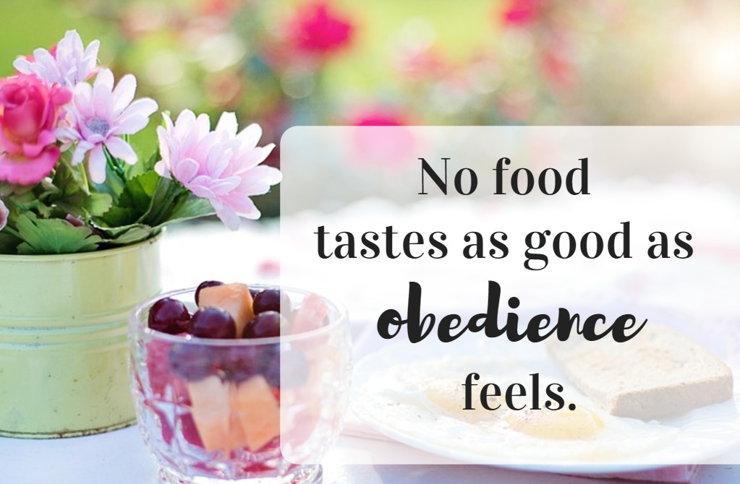
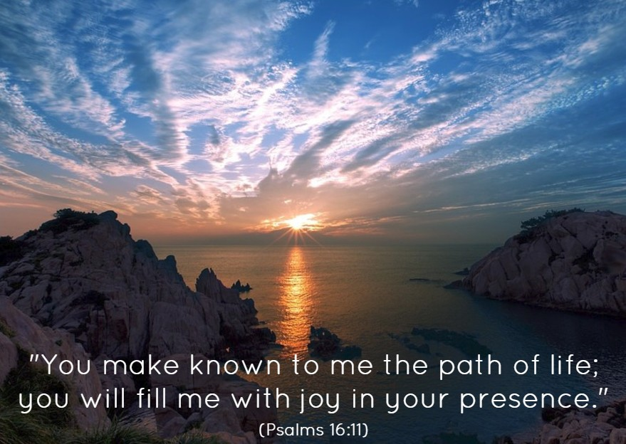
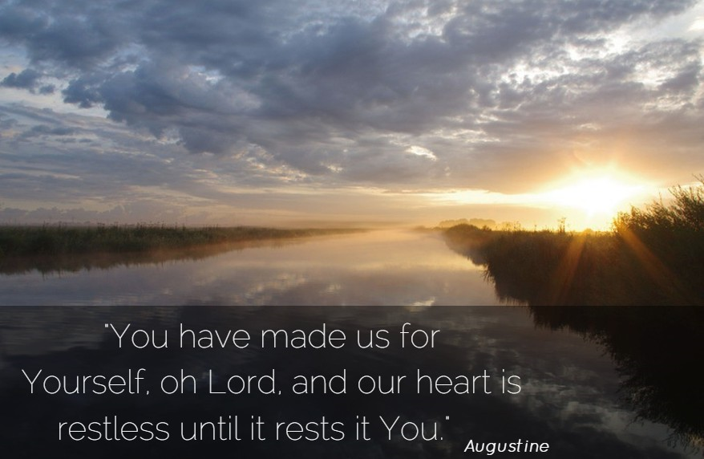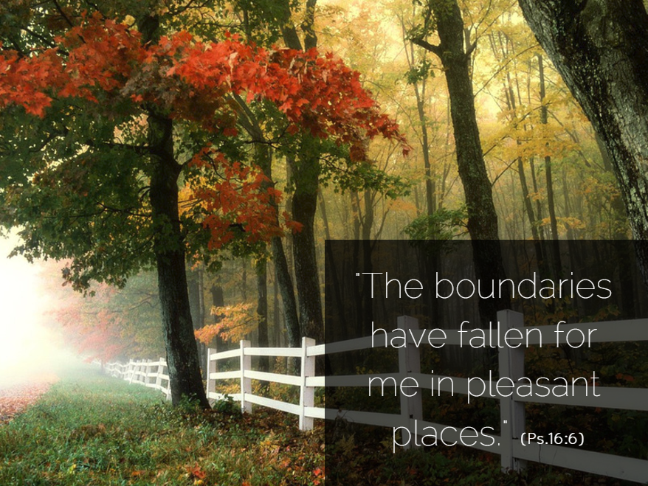
“Escape (into food) is the easy route, but it leads me away from God. He is the answer to failure; I need Him more than ever when I’ve failed. He wants to help me.”

(from Freedom From Emotional Eating
by Barb Raveling, page 53)

Lifelong boundaries in the area
of food make our lives better because they keep us safe. Yes, they cramp our style, but our style needs to be cramped because there are (sad and serious) consequences to eating what
we want when we want.”

(from A Taste For Truth by Barb Raveling, p. 13)

